Name & Period: __Austin Jenchi – 8th Period______

**Homework #2:** Due Friday, February 6 in the Dropbox.

**Exercise 2.1 – Variable Names**

The Python interpreter has strict rules for variable names. Which of the following are legal Python names? ***If the name is not legal, state the reason.***

1. and

No, used as a Boolean operator.

2. _and

Yes

3. var

Yes

4. var1

Yes

5. 1var

No, starts with a number.

6. my-name

No, dash is considered an operator for subtraction.

7. your name

No, the interpreter assumes the space ends the variable name.

8. COLOR

Yes

**Exercise 2.2 – Types**

It is important that we know the type of the values stored in a variable so that we can use the correct operators (as we have already seen!). Python automatically infers the type from the value you assign to the variable. Write down the type of the values stored in each of the variables below. Pay special attention to punctuation: values are not always the type they seem!

5. e = ’True’

String

6. f = 17

Integer

7. g = ’17’

String

8. h = True

Boolean

9. i = ’3.14159’

String

**Exercise 2.3 – Boolean operators**

Boolean operators can seem tricky at first, and it takes practice to evaluate them correctly. Write the value (True or False) produced by each expession below, using the assigned values of the variables a, b, and c. Try to do this without using your interpreter, but you should check yourself when you think you’ve got it. Hint: Work from the inside out, starting with the inner-most expressions, like in arithmetic.

a = False b = True c = False

1. b and c

False

2. b or c

True

3. not a and b

True

4. (a and b) or not c

True

5. not b and not (a or c)

False

**Exercise 2.4: Rock, Paper, Scissors**

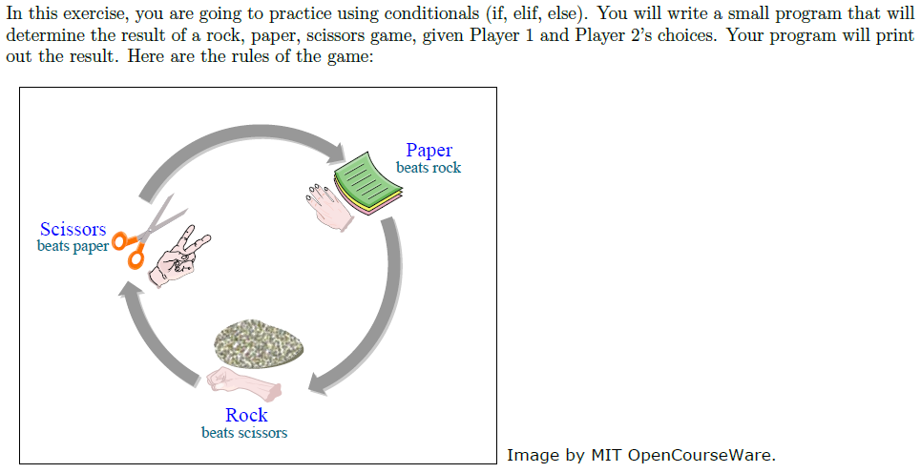

1. First create a truth table for all the possible choices for player 1 and 2, and the outcome of the game. This will help you figure out how to code the game!

|  |  |  |
| --- | --- | --- |
| **Player 1** | **Player 2** | **Result** |
| Rock | Rock | Tie |
| Rock | Paper | Player 2 |
| Rock | Scissors | Player 1 |
| Paper | Rock | Player 1 |
| Paper | Paper | Tie |
| Paper | Scissors | Player 2 |
| Scissors | Rock | Player 2 |
| Scissors | Paper | Player 1 |
| Scissors | Scissors | Tie |

1. Create a new file rps.py that will generate the outcome of the rock, scissors, paper game. The program should ask the user for input and display the answer as follows:

Player 1? rock

Player 2? scissors

Player 1 wins.

The only valid inputs are rock, paper, and scissors. If the user enters anything else, your program should output “This is not a valid object selection”. Use the truth table you created to help with creating the conditions for your if statement(s).